CDJMM Software Solutions.

Deliverable #3
CS131-02 Fall 2011
October 18, 2011

Contents
1.0 Introduction 4
1.1 Purpose of this Document 4
1.2 Scope of the Development Project 4
2 General Description 5
2.1 Glossary 5
2.2 User Characteristics 5
2.3 Product Perspective 6
2.4 System Functional Requirements 7
2.5 General Constraints and Assumptions 7
2.6 User View of Product Use 8
3 Specific Requirements 13
3.1 Interface Requirements 13
3.1.1 User Interface 13
3.1.2 Hardware Interface 15
3.1.3 Software Interface 19
3.1.4 Communication Interfaces 20
3.2 Detailed Description of Functional Requirements 21
3.2.1 Template 21
3.2.2 Data Dictionary 23
3.3 Non-Functional Requirements 24
4 Object Oriented Analysis (OOA) – UML 25
4.1 OOA 25
4.1.1 Case Diagram 25
4.1.2 Use Cases 26
5 Special Remarks or Comments 33
6 References or Resources Used 33
7 Team Member’s Roles and Approval 33
7.1 Team Member’s Roles 33
7.2 Team Member’s Signatures 34

Introduction

Purpose of this Document
This Software Requirement Specification (SRS) document describes the functions and performance requirements for the Sacramento State Aquatic Center's computerized rental system. This new computerized rental system is a web base system designed to speed up the rental process.

Scope of the Development Project
The product to be developed is for Sacramento State Aquatic Center (SSAC). The product will be used as a replacement for the current paper-based system that is currently in place. The new computerized system will allow customers to rent their equipment and this system will also allow the SSAC's staff and administrators to access and modify the rental system as needed.
There are some constraints to this new computerized system that will need to be taken into account. First, there is specialized equipment that can only be rented by customers who have taken a class or lesson. Second, there are some boats that have restraints on the number of seats, and also on the combination of adults and children. Third, there must be a way to check the validity of Sac state students, alumni, facility and staff in order to receive discounts. Lastly, the station where the customers have to check-in would have to be outside because of space limitations.

General Description

Glossary
- Admin - Short for "administrator", it refers to either a responsible person or the job functions (e.g., managing and maintaining the systems) or root privileges given to such a person.
- DBMS (Database Management System) - is a software package with computer programs that control the creation, maintenance, and the use of a database.
- Functional Requirements - Functional requirements capture the intended behavior of the system. This behavior may be expressed as services, tasks or functions the system is required to perform.
- Non Functional Requirements - a non-functional requirement is a requirement that specifies criteria that can be used to judge the operation of a system, rather than specific behaviors.
- R.I.D (Rental Identification) - A R.I.D number will be given to a single customer to identify that specific customer and his or her belongings (car keys).
- SQL (Structured Query Language) - is a standard language for accessing and manipulating databases.
- SRS (System Requirements Specification) - a complete description of the behavior of a system to be developed. It includes a set of use cases that describe all the interactions

User Characteristics
- Customer – Customers of the Sacramento State Aquatic Center. In reality, customers will have a wide range of background and experience, but it will be assumed that any given customer has no experience. Customers will need to be able to log in, enter/update their personal information, and initiate a rental.
- Staff – Staff members of the Sacramento Stat
- e Aquatic Center. Staff members should attain a familiarity with a system. Staff members will need to verify and complete rentals, update Customer information, update certain Equipment information such as available quantities and generate reports.
- Admin – The Admin group includes the Office Manager (Heather Heieck), and IT personnel. Admin users will have extensive knowledge of the system and all of its functions. Admin users will have full edit and write privileges to the entire database including: Customer, Rental, Equipment, and Staff information.

Product Perspective

SCD

Output Rental Amount
Sacramento State
Aquatic Center
Rental Database

Input Customer and Rental Information
Input Equipment Information
Staff
Manager
Customer

System Functional Requirements
- Sign In
- Minors / 18 and over
- Waiver
- I.D. Collection
- Equipment Rental
- Sync to Class Database
- Inventory
- Hook Number
- Pervious Page / start over
- Check In Complete
- Return and Time Stop
- Admin Log In
- Profile Deletion

General Constraints and Assumptions

User View of Product Use

This is the Login/Register page. Customers may either login as returning customers or create a new user account.

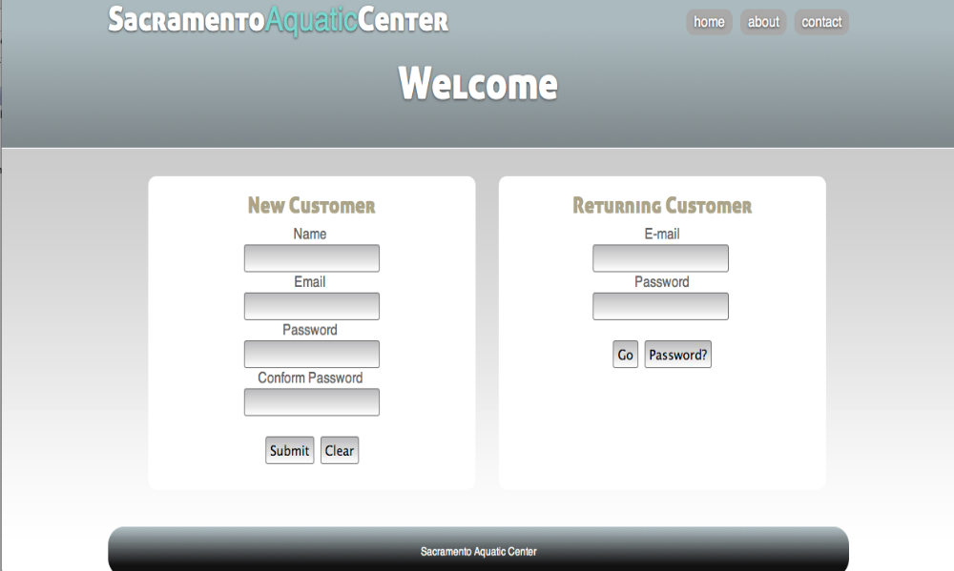

Once logged in, the customer can select what equipment(s) he or she wants to rent for the day. As the page shows, the customer will be able to select any of the equipment. This will not be the case for most people. Based on the class level, some of the items will be in red, denoting that they need to be certified before using the equipment. Some items will have a line through them; this will denote that the item is currently sold out.

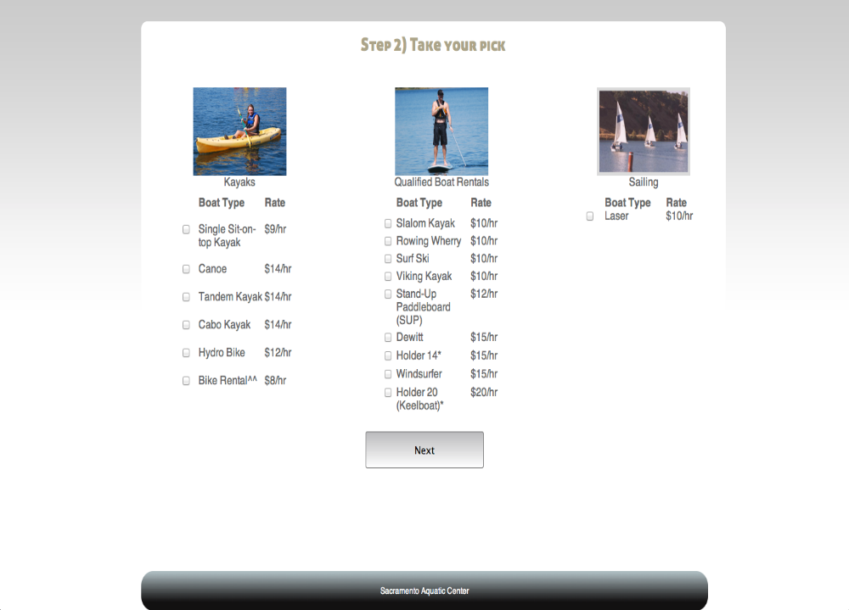

The page below looks barren now, however, it will allow for rental additional items; i.e. Helmet, life jacket, or even Gatorade...

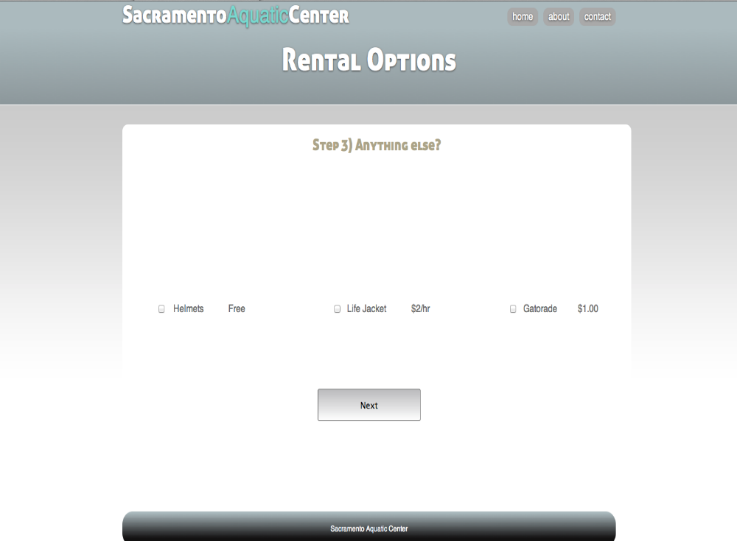

Once all of the technical stuff is taken care of, we need to note who is with them. In the below field they will be able to input the person’s name as well as their birth date. Note that the format is also there for them to use, however, if they fail to follow the format, our program will make up for it and use some regular expressions to determine which of the fields are birthdays and what is their name.

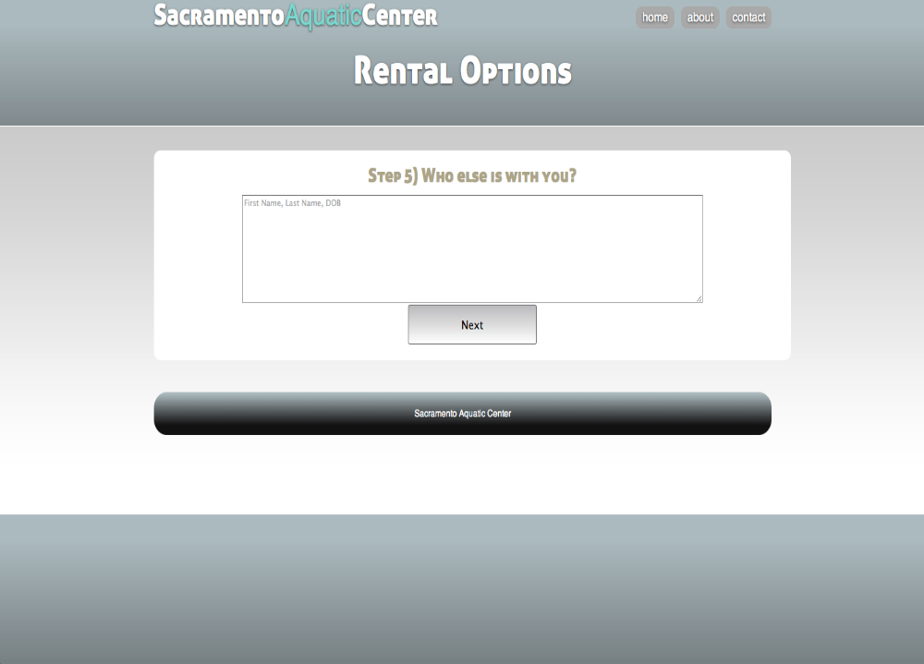

Last but not least, they will be guided to the office to take care of some procedural stuff. (We can include a summary of their transaction as well.)

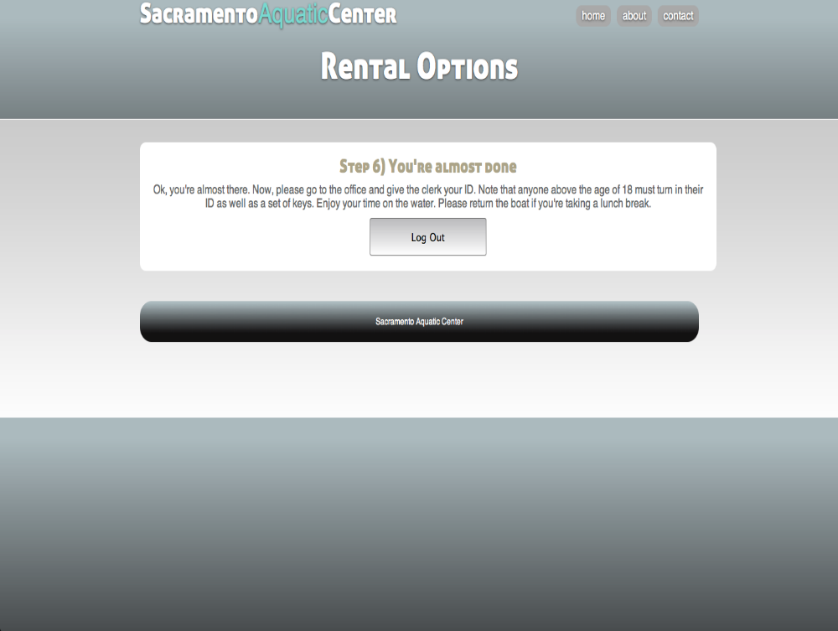

Specific Requirements

Interface Requirements

User Interface
Users of the web system will directly manipulate or interact with a terminal station. The following is an overview of the elements which the user can directly manipulate or control within the web system.
The system distinguishes between three sets of users:
- Customer Interfaces:
- New Customers User Interface:
The registration web page enables new users to create a username, enter phone number or password, and enter other identifying attributes needed to register a user into the system. Users fill this information and then are prompted to click a Submit button. There is also the option to click a Clear button to erase undesired entries if necessary.
- Current/Returning Customers User Interface:
The registration web page is divided into two parts such that the left is registration for new customers and the right is login for returning customers. This login for returning customers is intended to be quick and convenient, so that only email/phone number or email/password is needed to login to the system.
- Staff User Interface:
The staff will see a "current customer" webpage, which lists the most recent requests from customers who are waiting for a rental. It will have all pertinent information such as the name of the customer, the equipment desired to be rented as well as the quantity of the rental and how many other individuals are with the customer as a group.
The staff will also have access to a "sales webpage", which will give descriptive information on a particular customer's rentals, the duration of those rentals, and the final calculated cost (minus the cost of a pre-calculated grace period).
Additionally, the staff (just like the customers) will have their own login page, so that the system can uniquely identify which personnel handle which transactions.

- Administrator User Interface:
The administrator will have a master login to an area of the system not accessible by the staff (and of course the customers).
The administrator will have all of the privileges of the staff; she will be able to see not only current transactions, but also a history of transactions. The administrator will have access to a webpage to allow her to modify the costs of the various items in the queue of rental equipment. Such changes will be immediately visible in the transactions of subsequent customers.
The administrator will also have a reports interface to allow her to generate indicators relating to the overall business, such as history of sales, the number of customers, the number of rentals, most popular item, etc. Each of these can be filtered to a particular time period.

Hardware Interface
Users of the "Aquatic Center Tracking System" will interface directly with various hardware components. Here is a description of the components and configurations of this hardware:

- Option 1: IBM-Compatible PC Base Station
This is a PC-based station on which customers could register or log into the system. Here are its components, interfaces and advantages:

- Laptop Unit:
  - Components:
    - Ethernet (preferably wireless) web-capable network card
    - Onboard graphical display.
    - Onboard keyboard for input.
    - Onboard touchpad for input.
    - Optional USB mouse.
    - Optional USB full-sized keyboard.
    - Optional HDMI large-screen display.
  - Mechanical:
    - Possible locking cable to prevent theft of hardware.
    - Possible ground-mount on which hardware is secured.
    - Not Implemented:
    - The onboard microphone, which could potentially be used for voice capture rather than typing.
    - The onboard camera, which could potentially be used for photo identification.
    - The onboard sound device, which could potentially be used to give audio feedback per user action.
  - Advantages:
    - Portable.
    - Has the advantage of having a built-in display so that a separate monitor is not required.
    - Users will use the built-in keyboard to type or enter information.
    - Users will use the touchpad.
  - Disadvantages:
    - Small screen size may make viewing uncomfortable.
    - Small onboard keyboard may make typing more difficult or uncomfortable.
    - Small onboard touchpad may make cursor movement more difficult or uncomfortable.
    - Small size of laptop leaves it more susceptible to theft if not using locking device or ground-mount.
  - Sample System:
    - Model: Dell Inspiron 14R
    - Retail Estimate: $700
    - Processor: 2nd Generation Intel® Core™ i3-2310M
    - Processor: 2.10 GHz
    - Operating System: Windows 7 Home Premium, 64-Bit
    - Memory: 4GB Shared Single Channel DDR3 Memory
    - Chipset: Mobile Intel® 6 Series Express Chipset (HM67)
    - Video Card: Intel HD Graphics/HD Graphics 3000 with up to 1.6GB Dynamic Video Memory
    - Display: 15.6 inch display (1366x768)
    - Audio/Speakers: SRS Sound HD, Built-in Microphone
    - Optical Drive: Internal tray-load DVD+/-RW
    - Battery: 6-cell 48WHr Li-Ion Battery
    - Camera: 1.0MP Integrated 1280x720 native HD Webcam
    - Wireless: Intel® Centrino® Wireless-N 1030 (1x2 bgn+Bluetooth)
    - Accessible Ports: USB (4), HDMI, VGA, RJ45 LAN, AC Adapter Connector, Audio Jack, Microphone Jack
    - Dimensions: Width 13.50", Height 1.20", Depth 9.68", Weight 4.89lbs

- Option 2: Mac-Based Base Station
This is a MAC-based station on which customers could register or log into the system. Much of this section is identical to the IBM-Compatible Laptop system mentioned above. Here are the components, interfaces and advantages mac-Based station:
- MacBook Unit:
  - Components: identical to laptop unit.
  - Mechanical: identical to laptop unit.
  - Not Implemented: identical to laptop unit.
  - Advantages: identical to laptop unit.
  - Disadvantages: identical to laptop unit.
  - Sample System:
    - Model: MacBook Pro
    - Retail Estimate: $2000
    - Processor: 2.0GHz quad-core Intel Core i7
    - L3 cache: 6MB shared
    - Memory: 4GB (two 2GB SO-DIMMs) of 1333MHz DDR3 SDRAM
    - Hard Drive: 500GB Serial ATA; 5400 rpm
    - Optical Drive: 8x SuperDrive (DVD±R DL/DVD±RW/CD-RW)
    - Graphics: Intel HD Graphics 30005 and AMD Radeon HD 6490M with automatic graphics switching
    - Graphics Memory: 256MB GDDR5
    - Video: FaceTime HD camera; Thunderbolt port with support for DVI, VGA, dual-link DVI, and HDMI
    - Display: 15.4-inch (diagonal) LED-backlit glossy widescreen display, 1440-by-900 resolution
    - Expansion: One Thunderbolt port (up to 10 Gbps), one FireWire 800 port (up to 800 Mbps), two USB 2.0 ports (up to 480 Mbps), SDXC card slot
    - Audio: Stereo speakers with subwoofers, omnidirectional microphone, audio line in minijack (digital/analog), audio line out/headphone minijack (digital/analog)
    - Networking: 10/100/1000BASE-T (Gigabit) Ethernet
    - Wireless: Wi-Fi (based on IEEE 802

- Option 3: Mobile Based device.
- Components:
  - Ethernet (preferably wireless) web-capable network card
  - Onboard graphical display.
  - Onboard Graphical keyboard for input.
  - Onboard touchpad for navigation.
- Sample System:
  - HTC Flyer
  - Acer Iconia
  - T-Mobile Gslate
  - Samsung Slide
  - BlackBarry Playbook
  - Asus Eee Pad
  - Motorola Xoom
  - Apple iPad
- Advantage (Applies to all)
  - Mobile.
  - Ecstatically pleasing.
  - No mess.
- Disadvantage:
  - Securing the device so that it is not stolen.
  - Glare from the sun outdoors.

Software Interface
Users of the "Aquatic Center Tracking System" will interface directly with various software components. Here is a description of the components and configurations of this software:
- Direct User Interface:
  - Operating System: Windows 7 (or Mac OS X)
  - Supported Web-Browsers:
    - Internet Explorer 6 or later
    - Mozilla Firefox 5 or later
    - Google Chrome (Any)
    - Safari 4 or later
    - iOS 3.0 Safari or later
    - Android Dolphin Browser.

- Direct Staff Interface:
  - Web-based management of customer registration/rental/sales info
    - Web-based html report displaying admin-related indicators (pending implementation)
    - Excel report using VBA backend to generate reports and indicators according to admin preferences (pending implementation)

- Developer Interface:
  - Web Host (Server)
    - capable of running PHP scripts
    - supports MySQL backend
  - PHP MyAdmin
    - manages the MySQL database
    - MySQL backend stores tables for the tracking system's database
  - XAMPP
    - contains elements for debugging/running PHP scripts on local machine:
    - contains the following elements:
      - Apache -- a web server software installable on local machine
      - MySQL -- an RDBMS utilized to create the database for the system
      - PHP -- runtime to be stored on the local machine
  - PHP Scripting IDE
    - facilitates creation, editing, testing and debugging of PHP code
    - example: Netbeans w/ PHP engine

Communication Interfaces
The "Aquatic Center Tracking System" will have the following communication interfaces.
- Customer's Base Station to Server:
The laptop base station on which the customers interact will be connected via internet to the server on which the database resides. There will be constant input/output communication between the base station and the server. The various data elements communicated from the laptop base station to the server are:
- Customer registration information:
  - Customer full name
  - Customer username
  - Customer phone number
  - Customer equipment eligibility
  - Customer status as new or current
- Customer rental information:
  - Particular equipment desired for rental
  - How many of each equipment desired
  - The time at which the transaction is finished and logged
  - Customer registration/check-in time.

- Server to Staff's Base Station :
The staff's base station communicates with the server by requesting data from the database. Here are some of the data elements involved in this network:
- Current customer ID
- Current customer rental time
- Current customer desired rental equipment data
- Transaction information from which to calculate final cost
- Transaction information from which to generate reports

Detailed Description of Functional Requirements

Template
- Sign In
  - Purpose / Description: Log in to the system.
  - Inputs: First name, Last Name, Phone number.
  - Processing: Customers enter First name, Last Name, Phone number in a database. These profiles are saved in the database for future equipment rentals.
  - Outputs: Customer is signed in.
- Minors / 18 and over
  - Purpose / Description: Minors must be listed with an adult in the database.
  - Inputs: Minor and 18 or older checkboxes.
  - Processing: Option will distinguish every rider as a minor or an adult.
  - Outputs: Adults with these minors.
- Waiver
  - Purpose / Description: Read and check off waiver.
  - Inputs: Read check box.
  - Processing: The check box serves as a signature for waiver.
  - Outputs: All riders must verify that they have read the waiver by marking the check box.
- I.D. Collection
  - Purpose / Description: Explain ID collection process.
  - Inputs: All riders 18 and over.
  - Processing: All riders must turn in an ID and Main contact must turn in current D.L.
  - Outputs: proceed to office in order to complete check in.
- Equipment Rental
  - Purpose / Description: Equipment information and prices.
  - Inputs: Equipment selection.
  - Processing: Customer will select equipment.
  - Outputs: Equipment selected will be checked out under customer profile.
- Sync to Class Database
  - Purpose / Description: Sync to Class database.
  - Inputs: FristName, LastName, Phone number, and special equipment clearance.
  - Processing: Sync will create a profile for people who have special equipment clearance in the Class database.
  - Outputs: People that have taken a class will have a profile.
- Inventory
  - Purpose / Description: Current Inventory.
  - Inputs: Add, remove, repair, staff.
  - Processing: Method of keep track off current inventory in use, in repair, staff use, and remove equipment.
  - Outputs: Up to date inventory list.
- Hook Number
  - Purpose / Description: Key tag.
  - Inputs: Key tag number.
  - Processing: filing system for car keys.
  - Outputs: To maintain an efficient key filing and finding system.
- Pervious Page / start over
  - Purpose / Description: Previous Page / start over.
  - Inputs: Previous page and start over buttons.
  - Processing: Capability to move to previous pages or completely start over.
  - Outputs: The previous page or sign in page.
- Check In Complete
  - Purpose / Description: Check in complete.
  - Inputs: Complete pre-check in.
  - Processing: Direct customer to proceed inside with ID cards.
  - Outputs: Completed pre-check in.
- Return and Time Stop
  - Purpose / Description: Stop rental.
  - Inputs: Stop Time.
  - Processing: Staff will stop the time on rental equipment.
  - Outputs: Total time equipment rented.
- Admin Log In
  - Purpose / Description: Admin Log In.
  - Inputs: Username and Password.
  - Processing: Admin will have a separate account with special clearances.
  - Outputs: Administrative access.
- Profile Deletion
  - Purpose / Description: Deletion of customer profile.
  - Inputs: Last rental date.
  - Processing: If a customer has not rented within 7 years, the profile will be deleted from the database.
  - Outputs: Database consists of customers who have rented in the last 7 years.

- Generate Report
  - Purpose / Description: Generate a rental activity report for selected time frame.
  - Inputs: Date range for the report
  - Processing: The system will query the Rental Table of the Database for all rental entries that were generated within the date range
  - Output: Rental Activity Report formatted in HTML or exported to Excel.

Data Dictionary

Name | Description | Type | Range
First Name | Customer’s First Name | Var char
Middle Initial | Customer’s Middle Initial | Var char
Last Name | Customer’s Last Name | Var char
Phone Number | Customer’s Phone Number | Var char
Street | Customer’s Street Address | Var char
City | Customer’s city abbreviation | Var char
Zip | Customer’s zip code | Var char
Adult or Minor | Customer’s age | Bool
Check-in Time | Customer’s check-in time | Time Stamp
Check-back-in Time | Customer’s time when the equipment are returned | Time Stamp
Rental Identification (RID) | Customer’s rental identification | int
Price | Calculated amount that the customer needs to pay

Non-Functional Requirements
- Usability:
  - The simplicity of this system will speed up the rental process.
  - Straightforward screens and navigations will make sure that the user will be comfortable with the process.
  - Easy and flexible backend for the staff and the administrators to modify.
- Reliability:
  - The system will be reviewed and approved prior to development of the software product to ensure quality design.
  - Steps will be taken to make sure that the system will always perform according to its function.
- Performance:
  - The system will be designed to allow for minimum response time to speed up the performance of the system.
  - The familiarity of the screens and navigations will enhance the rental process check-in and check-out.
- Security:
  - The system will only be accessed by Administrator(s), Staff, and Customers with valid login and passwords.
  - There are different levels of system access: from full access of the Administrator(s) to the limited access level for customers.

Object Oriented Analysis (OOA) – UML

OOA

Case Diagram
Customer
Staff
Admin

Login Page
Rent Equipment
End Rental for the day
Modify Rental
Modify Customer Info
Modify Inventory
Generate Report

Use Cases
- Login Page
  - Use Case Number: UC01
  - Actors: Customers
  - Overview: This use case captures the process of logging into the system. After logging in, the customer will begin the rental process.
  - References: R1
  - Related Use Cases: UC2
  - Flow Description: The user will enter their login credentials. If the credentials exist in the system, the user will proceed to the rental page
  - Alternate Flow Description: The user does not have an existing account. They will have to create an account before proceeding to the rental page.
  - Use Case Expansion:
Include
Customer
Login Page
Rental Page
- Rent Equipment
  - Use Case Number: UC02
  - Actors: Customers
  - Overview: This use case captures the process of initiating an equipment rental.
  - References: R2, R3, R5, R6, R7, R8, R10
  - Related Use Cases: UC1
  - Flow Description: Receive Customer information from UC1, the customer then selects the equipment that they would like to rent and lists all others who will be using the equipment. Minors must be accompanied by an adult. The waiver will be displayed and all riders must check a box to acknowledge that they have read it. The current time is captured as the Start Rental Time.
  - Alternative Flow Description: The customer decides to change or cancel the rental. Then can click an icon to either start over or go back to the previous screen.
  - Use Case Expansion:
Create Rental Record
Include
Rental Page
Customer
Extend
The customer information is retrieved from the login page
Login Page
- Modify Rental
  - Use Case Number: UC04
  - Actors: Staff, Admin
  - Overview: This use case captures the process of a Rental Record being modified by a Staff or Admin user.
  - References: R4, R8, R11
  - Related Use Cases:
  - Flow Description: The Staff or Admin user will collect and verify Rider ID’s, Issue Bracelets, and assign the hook number. The staff member will then edit the rental record with the hook number and checking a box to indicate that the rental has been verified.
  - Alternative Flow Description: In Special Circumstances, the Staff or Admin User may modify any other field in the Rental Record. This includes adjusting start and stop times, customer information, and equipment rented.
  - Use Case Expansion:
Admin
Staff
Include
Modify Rental Record
Modify Rental
- End Rental for the day
  - Use Case Number: UC03
  - Actors: Staff, Admin
  - Overview: This use case captures the process of ending an equipment rental.
  - References: R4
  - Related Use Cases:
  - Flow Description: After returning the equipment, the customer will return to the rental office where a staff member will end the rental time. When all equipment has been returned, the use will close the Rental Record and the system will then calculate and display the amount due for equipment rentals.
  - Alternative Flow Description:
  - Use Case Expansion:
Include
Display Amount Due
Include
Modify Rental Record
Admin
Staff
End Rental For the Day
- Modify Customer Info
  - Use Case Number: UC05
  - Actors: Staff, Admin
  - Overview: This use case captures the process of modifying specific customer information. This can be used to reset Customer Login information
  - References:
  - Related Use Cases:
  - Flow Description: The Staff or Admin user will enter the Edit Customer Information screen and can modify the Customer Information.
  - Alternative Flow Description:
  - Use Case Expansion:
Modify Customer Record
Modify Customer Info
Include
Staff
Admin
- Modify Inventory
  - Use Case Number: UC06
  - Actors: Staff, Admin
  - Overview: This use case captures the process of modifying specific equipment information in the database. For the staff users only available quantities are able to be adjusted. For admin users, any field in the equipment table may be modified.
  - References:
  - Related Use Cases:
  - Flow Description:
  - Alternative Flow Description:
  - Use Case Expansion:
Modify Equipment Record
Modify Inventory
Admin
Staff
Include
- Generate Report
  - Use Case Number: UC07
  - Actors: Staff, Admin
  - Overview: This use case captures the process of generating an activity report from the Rental Table of the database.
  - References: R14
  - Related Use Cases:
  - Flow Description: A Staff or Admin user will select the “Generate Report” option, select the date range for the report, and the desired output method (HTML, or Excel)
  - Alternative Flow Description:
  - Use Case Expansion:

Rental Activity Report
Generate Report
Admin
Staff
Include

Special Remarks or Comments

References or Resources Used

Team Member’s Roles and Approval

Team Member’s Roles
- CJ Thakor
  - Section 2.1
  - Section 2.2
  - Section 3.2.1
  - Section 3.2.2
- Darby Hannon
  - Section 2.3
  - Section 2.4
  - Section 4.1.2
  - Document integration and assembly
- Madelyn Bachiller
  - Section 1.1
  - Section 1.2
  - Section 3.2.2
  - Section 3.3
- Mike Poku
  - Section 3.1.1
  - Section 3.1.2
  - Section 3.1.3
  - Section 3.1.4
- Joubin Jabbari
  - Section 2.6 (Screen captures and descriptions
  - 4.1.1

Team Member’s Signatures
- CJ Thakor:

- Darby Hannon:

- Madelyn Bachiller:

- Mike Poku:

- Joubin Jabbari:

